A Forest Attribute Mapping Framework: a Pilot Study in Remote Northern Canada

**Abstract to review**

A methodological framework is presented that utilizes field plot, airborne laser scanning (ALS), and geoscience laser altimeter system (GLAS) data to estimate forest attributes over a 200,000 km2 area in Northern Canada. The framework is implemented to scale up forest attribute models from field data to intersecting ALS data, and then to GLAS spaceborne laser altimetry footprints. GLAS data are sequentially filtered and submitted to the k-nearest neighbour (k-NN) imputation algorithm to yield regional estimates of stand height and crown closure at a 30 m resolution. Resulting outputs were assessed against independent ALS data to evaluate regional estimates of stand height (mean difference=1.4 m) and crown closure (mean difference=5.5 %). Additional assessments were performed as a function of dominant vegetation type and ecoregion to further evaluate regional products. These attributes form the primary descriptive structure attributes that are typical of forest inventory mapping programs, and provides insights as to how they can be derived in northern boreal regions where field information and physical access is often limited.

# Introduction

The health and sustainability of forests in the boreal are of increasing concern, particularly as the circumboreal regions of the planet are warming and projected to be undergoing climatic changes most rapidly (Winton 2006, IPCC 2013, IPCC 2014). Approximately 33% of the world’s forests are categorized as boreal, with approximately 28% of this forest type falling within Canada (Brandt 2009, NRCan 2015). In Canada’s northern Taiga Plains Ecozone, evidence of permafrost thaw and changes in forest fire disturbance are already being reported, raising concerns regarding changes to forest structure and future delivery of forest ecosystem services (Helbig et al. 2016). The primary means of acquiring information regarding the structure and condition of a forest in Canada, is through a forest inventory (Gillis 2001, Wulder et al. 2004, Gillis et al. 2005), the provision of which has primarily been based on the interpretation of analogue and digital aerial photographs (Leckie and Gillis 1995, Hall 2003). Over vast, largely inaccessible forested areas in northern boreal regions such as the Northwest Territories (NWT), it would be cost prohibitive to complete a seamless coverage based on such methods. As a result, existing inventory data is sparse and inconsistent because of varying vintage, changes in data definitions and measurement standards over time (Smith 2002). Aside from forest inventory data, the most spatially complete vegetation information of the NWT serving as a reconnaissance inventory was completed as part of the Earth Observation for Sustainable Development of Forests (EOSD) project to complete a land cover map over the forested areas of Canada for circa 2000; this included the distribution of four main forest types: wetland, coniferous, deciduous, and mixedwood (Wulder et al. 2003). To provide a more current and consistent information base, the EOSD land cover map was redone in 2007. At present, multi-sensor remote sensing data and models are being used to estimate forest structure, stand volume and aboveground biomass as value-added products within the framework of the circa 2007 EOSD land cover maps (Hall et al. 2012).

Airborne Laser Scanning (ALS) data, and satellite-based Geoscience Laser Altimeter System (GLAS) data have been extensively investigated for deriving forest structure information such as biomass, stand height and canopy density (Nilsson 1996, Lefsky et al. 2002, Abshire et al. 2005, Harding and Carabajal 2005, Schutz et al. 2005, Neuenschwander et al. 2008, Sun et al. 2008, Hopkinson and Chasmer 2009, Hopkinson et al. 2011). These sensors have become valuable tools for measuring and validating estimates of forest structure in remote regions (Nelson et al. 1984, Lefsky et al. 2002, Rosette et al. 2008, Hopkinson and Chasmer 2009, Mahoney et al. 2014). When combined, spatially extensive spaceborne observations, ALS data samples, and *in situ* field plot data can be used to develop frameworks that scale parameters from one data source to the next in order to achieve regionally mapped products. Similar approaches have been adopted in various forms by many for regional mapping (Nelson et al. 2009, Nelson et al. 2009, Beaudoin et al. 2014, Margolis et al. 2015); moreover, such approaches have recently been favoured by government agencies, such as Australia’s Terrestrial Ecosystem Network (TERN).

The primary objective of this study was to develop and test a methodological framework that utilizes varying distributions of spatial data to yield regional products of two value-added forest parameters: stand height and crown closure. The secondary objective was to generate spatially-contiguous regional maps of these attributes using the k-Nearest Neighbour (k-NN; Altman (1992)) statistical method of imputation. A methodological framework was developed to document the workflow by scaling field plot data to ALS data to GLAS spaceborne data, which were then integrated with the k-NN imputation algorithm.

# Study Area and Data

## Study Area

The region of interest (ROI) was an eight Landsat Thematic Mapper scene area, occupying approximately 200,000 km2, covering the southern portion of the Canadian Taiga Plains ecozone in the NWT, Yukon Territory (YT), Alberta (AB), and British Columbia (BC; Figure 1). This ecozone contains diverse forest stands ranging from; wet, open stands of black spruce (*Picea mariana*) and larch (*Larix laricina*) with traces of white birch (*Betula papyifera*), to variable pure and mixed conifer stands dominated by white spruce (*Picea glauca*), jack pine (*Pinus banksiana*) and black spruce; to mixedwood stands of varying density dominated by trembling aspen (*Populus tremuloides*), balsam poplar (*Populus balsamifera*), white/black spruce and jack pine to varying degrees of species composition (Ecosystem Classification Group 2007). The Taiga Plains ecozone is divided into ecoregions which describe vegetation and topographic patterns in a regional climatic framework. In the context of the Taiga Plains, subdivided ecoregions describe physiographic characteristics (i.e. plains, plateaus, and hill systems) and geographic features (i.e. major rivers or lakes) (Ecosystem Classification Group 2007). Multiple sources of data were acquired across the ROI, including *in situ* field plots, ALS point cloud data, and GLAS waveform data.

Mean summer temperatures in the region range from 7°C in the north to 14°C in the south, whereas mean winter temperatures of -15°C are common in the south, compared to -26°C in northern areas. Snow cover and freshwater ice typically last for six to eight months, and discontinuous permafrost is widespread throughout the area. Although wetlands and bogs are common throughout, the area receives little rainfall, between 200 mm to 500 mm annually (Ecosystem Classification Group 2007).

## Field Data

A total of 47 field plots near Fort Simpson were employed in this study, where diameter at breast height (DBH), tree height, species composition, and crown closure attributes were measured within each plot. The field plots were 400 m2 in size and established in coniferous, deciduous, and mixedwood stands in support of an ALS survey (described below). Only 41 plots fell within the survey extent, 3 of which were removed because of inadequate ALS data, resulting in a total of 38 field plots available for ALS model development (Figure 1).

Stand height was defined as the mean height of all trees greater than or equal to Lorey’s mean height within the plot. Lorey’s mean height is a function of the mean basal area, whereby individual trees are weighted in proportion to their cross-sectional area at a height of 1.3 m (Philip 1994). Only trees exhibiting a diameter ≥ 5 cm were used to compute Lorey’s mean height. Densiometer measurements from each plot (excluding NFI) were transformed to crown closure by the method of Lemmon (1956). Crown closure was derived from the mean of 5 densiometer measures recorded at the plot centre and plot corners.

## ALS Data

On August 15, 2007, a 310 km2 area ALS survey was flown near Fort Simpson to cover the geographic extent of the field plot data. An Optech ALTM-3100 sensor was used onboard a de Havilland DHC-6 Twin Otter at an altitude range between 550 and 650 m above ground level. Data were acquired with a pulse repetition frequency (PRF) of 33 kHz, scan rate of 38 Hz, and a scan angle of ±20° which resulted in a sampling density of at least 1 return per square meter. During the survey the laser power supply was degraded due to a hardware fault resulting in a low density of ground returns over the study area. The Fort Simpson data were utilized in this study to develop models of stand height and crown closure with field plot data.

A second ALS survey under the concept of ‘LiDAR (light detection and ranging) plots’ was flown in transects across Canada between June 14th and August 20th, 2010 using the same Optech ALTM-3100 onboard a twin engine PA-31 Piper Navajo (Wulder et al. 2012). This dataset was used as an independent dataset for validation purposes. Of the acquired data, full or portions of 9 transects fell within the region of interest (Figure 1), all with similar survey configurations; above ground altitude from 600 m to 1900 m, PRF from 50 to 70 kHz, and scan angle from 15° to 20° (Hopkinson et al. 2011). The LiDAR plots ALS survey data set comprises a national coverage that have similarly been used in studies to estimate, calibrate and validate several forest inventory attributes such as canopy height, basal area, gross stem volume, canopy density indices, and aboveground biomass (Hopkinson et al. 2011, Wulder et al. 2012, Bolton et al. 2013, Zald et al. 2016). LiDAR point clouds from both ALS surveys were processed to 25 x 25m raster cells to generate a suite of metrics using FUSION (McGaughey 2010).

## GLAS Data

Throughout this study, release 33 of GLAS global altimetry raw waveform data (GLA01), waveform-based range corrections (GLA05), and global land surface altimetry data (GLA14) (Brenner et al. 2003, Zwally et al. 2011) were employed to model forest attributes stand height and crown closure. Both GLA01 and GLA05 data were used to estimate metrics directly from the waveform energy profile, whereas GLA14 data were used for quality control and extracting laser footprint geometries. Of all the available laser campaigns (temporally discrete, approximately 1 month long periods of data acquisition), data were restricted to L2A and L3A only. These campaign footprints were selected as they were the only data to coincide within the Fort Simpson ALS geographic extent, were acquired at similar phenological states to each other (fall), and contained footprints that were not acquired during winter (thus minimizing the influence of snow cover). L2A data were acquired between 25th September and 19th November 2003 with footprints exhibiting a semi-major axis of 99.9 m and eccentricity of 0.88. L3A data were acquired almost a year later between 3rd October and 8th November 2004, with a semi-major axis of 55.8 m, and eccentricity of 0.57. A total of 15,967 L2A, and 13,301 L3A footprints were available before quality control measures were executed. A more in depth description of the GLAS data acquisition strategy, and a comparison of unique GLAS mission properties and their suitability for forest mapping was presented in Mahoney et al. (2016).

***Figure 1.***

# Methods

The developed framework (Figure 2) illustrates how forest attribute models were generated between field and ALS data, which in turn were used to support development of GLAS modelled attributes. GLAS attributes were filtered and each level of quality controlled data was utilized as inputs for the k-NN imputation method. The accuracy of regional outputs from each filter was assessed against external ALS data, where available. The standard deviation of each output was calculated and used in conjunction with empirical distribution statistics (mean and standard deviation) from field plot, ALS, and GLAS modelled attributes to propagate uncertainty to regional estimates via Monte Carlo uncertainty propagation techniques.

***Figure 2.***

## ALS Models

Field data within the Fort Simpson ALS survey area were employed to develop forest attribute models of stand height and crown closure across the entire survey extent on a 25 m grid. During model derivation, each forest attribute was compared against multiple FUSION-derived ALS metrics from which multiple linear regression and nonlinear multiplicative power models were compared to find the optimal model form of best fit throughout the range of data (i.e. by comparing coefficient of multiple determination – adjusted R2, root mean square error – RMSE, cross-validation mean prediction error – MPE between each of the fitted statistical models); if no difference was noted between model fit statistics, the model exhibiting the greatest predictive range was favoured. For each metric, a constant variance BPK (Breusch-Pagan) test for heteroscedasticity was employed to determine if the statistical model residual variance was dependent on the independent variables used in the model. Rejection of the hypothesis of homogeneity of variance would result in selection of simpler functions of a single multiplicative power model to derive a function for estimating the forest structure attribute.

ALS models of stand height were based on direct estimates of elevation percentile metrics from the ALS point cloud, where only points > 2 m were considered to negate the contribution of tree and shrub understorey vegetation; i.e. p95 is the 95th percentile and represents the elevation at which 95% of points > 2 m occur. The estimation of stand height from a linear regression model as a function of a high percentile metric (p80, p90, p95, and p100 were interrogated here) above a minimum height (e.g., 2 m) results in a calibration between field plots and an ALS (or LiDAR) metric that has similarly been done in other studies (Bolton et al. 2013, Mora et al. 2013). The resulting function was submitted to a 5-fold cross-validation and an assessment of the model estimates was made through an objective function that minimizes the mean prediction error (MPE). A 5-fold cross validation was favoured as sub-setting data in this way resulted in multiple approximate 80% training to 20% testing data splits. The resulting MPE was calculated as the average of the results from the 5 repetitions in order to minimize any random bias associated with a single computation from a single random selection.

Crown closure models were based on an apparent foliage profile approach (Lovell et al. 2003, Riano et al. 2003, Coops et al. 2007), which requires the estimation of the probability of a gap from the top of the canopy to a given height class z (Pgap), in this case 2 m above the ground. Pgap is estimated by computing one minus the quotient of the sum of the total number of hits down to z (zj>z), and the total number of independent ALS shots (NAll) which includes both ground and canopy returns (Equation 1). The cumulative projected foliage area index from the canopy top to the height class z was then calculated (Equation 2).

|  |  |  |
| --- | --- | --- |
|  |  | (1) |
|  |  | (2) |

The parameter Lz was then used in a power function as a predictor of crown closure. Fort Simpson models were developed based on all coincident 38 field plots, and similarly submitted to a 5-fold cross-validation from which the MPE was computed.

No field measurements were available for stand height and crown closure model development across the LiDAR plots transects. Across the overlap region between the Fort Simpson ALS survey and the LiDAR plots survey, there was a highly linear association and a high statistical correlation in the p95 metric (i.e. r = 0.95, p = 0.000). Based on this result and given that LiDAR is a well-known estimator of height (Wulder et al. 2012), the stand height model developed from the Fort Simpson ALS survey was applied to the same metric across the LiDAR plots survey data within the study area. Under a similar logic, the model form for estimating crown closure from the Fort Simpson ALS survey was applied to the LiDAR plots survey. This approach was similarly employed by Wulder et al. (2012) in the context of LiDAR plots to meet the needs for forest plot information in support of large-scale programs. The similarity in the ecological regions over which both LiDAR surveys were acquired, and by the same sensor further supports this methodology. Estimating stand height and crown closure from the LiDAR plots survey provided an independent assessment of each attribute from which to evaluate estimates from the GLAS footprints. These estimates of stand height and crown closure were subsequently compared to independent (i.e. those that were not used in GLAS model development) intersecting GLAS footprint estimates by computing descriptive and correlation statistics.

## GLAS Models

### Determining Optimal GLAS Quality Control

GLAS waveform data quality is influenced by factors such as cloud contamination, atmospheric saturation and terrain slope (Lefsky et al. 2007, Chen 2010, Park et al. 2014); the presence of snow is also expected to influence the accuracy of varying forms of canopy height (and canopy density) metrics (Hayashi et al. 2013). A unique undertaking in this study was to demonstrate the effect of applying successive filters toward determining the optimal set of filters to apply to the GLAS waveforms.

GLAS height percentiles are strong predictors of stand height (Rosette et al. 2008, Simard et al. 2011, Mahoney et al. 2016) and hence were selected as a response variable for testing the response from the implementation of different filters in order to determine the optimum set. GLAS filtering was assessed against available coincident LiDAR plots data, where within footprint ALS representations of stand height were calculated as the area weighted mean of intersecting ALS cells within the footprint perimeter. The initial GLAS model of stand height assessed against the LiDAR plots data was based on overlapping footprints with the Fort Simpson ALS survey, after snow filtering had been applied; this filter was applied as it was expected to induce the greatest source of uncertainty. A total of five filter levels (labelled level 1 to level 5; Table 1) were investigated, each applied in succession. Level 1 data remained unfiltered, whereas globally applicable instrument and local height anomaly criteria’s were applied during level 2. Mean footprint slopes > 5° and any associated vertical bias (the product of the mean footprint diameter and the tangent of the estimated slope) that exceeded 25% of initially estimated stand height (Simard et al. 2011) were removed during level 3 filtering. Level 4 excluded snow affected footprints as a function of laser campaign appropriate cut-off dates; data acquired after 22/10/2003 for L2A, and 15/10/2004 for L3A were removed. Level 5 data were filtered by GLAS laser pulse emission energy, rationalized by the pursuit of maximizing signal-to-noise ratios (SNR). That is, larger emission energies typically yield a greater SNR, where the converse is true for lower emission energies making the latter more susceptible to waveform misinterpretation (Mahoney et al. 2016). In order to minimize the presence of such waveforms, those deemed to exhibit low emission energies were removed from analysis. That is, emissions < 28 mJ were deemed low energy (Mahoney et al. 2016) and removed from analysis. Table 1 notes the details of each filter, the number of GLAS footprints, and associated percent changes for each level of quality control; this allows estimates of the most influential filter to be interpreted.

It is important to note that with increased filtering, the number of GLAS footprints that were spatially coincident with the LiDAR plots geographic extent decreased. Therefore, in order to avoid bias, the largest number of coincident footprints common across all filter levels were sampled from the population of coincident footprints from each filter level. That is, after other filter applications, the level 5 filter (lowest) population exhibited only 20 coincident footprints, therefore only 20 footprints were also sampled from the populations of filter levels 1 thru 4. The agreement between the GLAS and LiDAR plots stand height estimates was indicated by the RMSE and mean absolute difference (MAD) for each level of filtering. The optimally filtered criteria was designated once the RMSE and MAD values remained constant before and after the application of an individual filter or after the level 5 filter was implemented.

***Table 1.***

### GLAS Model Development

The ALS data for Fort Simpson was the only available source from which to develop GLAS models of stand height and crown closure. This overlap facilitated the development of the initial model of stand height used to develop the GLAS filter optimization criteria (described above). As this initial model was based on data that were subject to the removal of snow afflicted data only, its provision of GLAS stand height estimates with the greatest achievable accuracy was uncertain. As a result, the GLAS footprints utilized in initial GLAS model development were revisited after the optimization criteria for GLAS data was defined from across the study area to determine if they required revision. After optimization an additional footprint was removed from analysis due to its proximity (< GLAS footprint diameter) to a relatively large waterbody (>> than GLAS footprint diameter). Given the high absorption of water in the (GLAS) 1064 nm waveband, interpretation of water affected energy profiles can often lead to spurious derivations of forest attributes. Post-optimization and the removal of potentially water contaminated footprints, a total of 43 ALS coincident footprints remained for the final model development of GLAS stand height and crown closure.

Similar to ALS model development, multiple (GLAS) metrics were tested against a dependent variable, each submitted to a BPK-test to determine model form. All available footprints were selected for model development due to the small sample population. For stand height model development, p85, p90, p95 and p100 were tested, calculated based on ground elevations identified by a standard parametrization of the Gaussian distribution fit to the last peak which effectively isolates the ground return (Harding et al. 2001, Brenner et al. 2003). Lower height percentiles were *a priori* assumed to exhibit less correspondence with stand height and were therefore not considered in model development (Mahoney et al. 2016). The optimal metric for modelling stand height was selected based on the same criteria as noted for Fort Simpson ALS model development, however, the need for cross-validation was mitigated by the use of intersecting independent LiDAR plots data to validate GLAS models. For crown closure, the GLAS equivalent (in reference to ALS) of Lz was calculated as the ratio of the cumulative sum of waveform energy from the canopy top to 2 m above the identified ground elevation and the cumulative sum of all above-ground energy. While theoretically similar to ALS return ratios, GLAS energy ratios require adjustment to account for the sensitivity of waveforms to apparent canopy and/or ground reflectance differences, that is, canopy returns reflect stronger or weaker than the ground (Harding et al. 2001, Lefsky et al. 2007). In order to negate these energy profile imbalances, waveform ground returns were scaled as a function of land cover. The portion of the waveform to be scaled was identified using a standard parametrization of the Gaussian distribution fit to the last peak as noted above. The most suitable scaling factors were applied based on the dominant vegetation type within each GLAS footprint, where the scaling factors 1, 0.25, and 2 were applied to coniferous, deciduous, and mixedwood dominated footprints, respectively. The application of such scaling factors was based on previous study data from within the same region (Hall et al. 2009).

## Regional Mapping

GLAS modelled estimates of stand height and crown closure were output to a 30 m grid via the k-NN imputation method (Altman 1992). This imputation method was selected as it has been widely applied in Europe, the United States and Canada as a tool for forest inventory mapping as a function of multi-source geospatial data (McRoberts et al. 2002, McRoberts et al. 2015). Regionally distributed GLAS estimated forest attributes were selected as model response variables and integrated with an optimal set (described above) of a possible 8 coincident 30 m raster products assigned as predictor variables (Table 2). Individual footprint representations of each predictor were calculated as the area weighted mean of predictor cells within the footprint perimeter.

***Table 2.***

Particular user input parameters submitted to the k-NN method can significantly change model outputs across the target set (defined as locations where an estimated response is desired). To ensure the utility of optimal user inputs, selections were screened subject to an optimization process as per McRoberts et al. (2015). That is, combinations of the neighbour weighting kernel, number of neighbours (k), and predictor selection were varied in pursuit of greatest overall model accuracy. Eight neighbour weighting kernels from Hechenbichler and Schliep (2004) were tested in combination with values of k ranging from 1 to 25, and different predictor combinations (from all combinations of 2, and 3 predictors etc. up to all predictors). The optimal combination of both input parameters and predictor variables used in the k-NN process was determined by which one produced the smallest mean square error (MSE) as calculated from a leave one out cross validation (Hechenbichler and Schliep 2004, Samworth 2012). The optimal value of k was expected to be large given the large amount of data that was available for model training, which expectedly increased algorithm complexity and computational intensity (McRoberts et al. 2015). As a mitigation strategy we followed the suggestion of McRoberts et al. (2002) and selected a smaller value of k that yields a MSE within 2% of what was initially deemed optimal. The optimization techniques for k-NN were applied separately for stand height and crown closure for the optimal set of GLAS footprint data (as determined by GLAS quality control measures).

## Uncertainties

Uncertainties associated with regional forest attribute estimates were explored to potentially identify areas of weakness in the various models employed in this study. Uncertainties associated with modelled attributes occur from measurements in the field plots, to ALS extents, GLAS footprints, and to 30 m regional estimates that propagate uncertainties at each step, all of which were subject to the quality of model development data employed at each step. Due to variations in population sizes at each modelling step, and to varying levels of spatial coincidence, Monte Carlo (MC) methods were employed to quantify regional product uncertainties (Hammersley and Handscomb 1964, Ogilvie 1984). As MC methods allow a ‘black box’ approach to model equation systems, the need to solve potentially complex first and second order derivatives, common in other methods, was negated. Furthermore, MC simulations avoid errors associated with the linearization of models, a concern when model forms are highly non-linear, as is the case for crown closure. It is important to note this method did not quantify unknown uncertainties such as the temporal disparity between datasets.

Monte Carlo simulations require the knowledge of the data distribution and its associated mean and standard deviation. Given a known data distribution, it is possible to relate the model response variable (Y) to some given model dependencies (x and p) via a simple function (Equation 3).

|  |  |  |
| --- | --- | --- |
|  |  | (3) |

To simulate uncertainties in Y, 1000 random values of x and p were generated from their respective empirical data distributions, and Y calculated for each. This yields a distribution of 1000 Y values from which the mean and standard deviation could be calculated. In this study f(x, p) took the form of a single or nested (i.e. to propagate from field to ALS to GLAS data) linear (stand height) or power function (crown closure). Given uncertainties were propagated from field plot scale to GLAS scales (and to regional scales, explained below), it was assumed that the GLAS data distribution was representative of the field data distribution, and in turn, that the field plot distribution was representative of the study area.

Uncertainty propagation through the k-NN algorithm was conducted on a unique cell basis, where all k nearest neighbours selected from the reference set used to estimate a response in unique cell were used to calculate the cell level standard deviation. Estimates of cell level statistics allowed the propagation of uncertainty from GLAS data to each cell via MC simulations, where each cell’s uncertainty represented an accumulated estimate of the standard deviation propagated from field plot through to regional products via ALS, and GLAS data.

## Regional Attribute Assessment

Regionally mapped products were assessed with respect to the LiDAR plots data, where an area weighted mean of intersecting cells from the former were compared with the latter. A 1% (12195) sample of all cells from the assorted LiDAR plots transects was randomly selected to assess k-NN outputs. In order to minimize the probability of spatial covariance, the minimum distance between sampled cells was always >75 m (i.e. three times the size of a single cell). Regional attribute maps were also evaluated via the LiDAR plots data as a function of within cell (dominant) forest vegetation type (coniferous, deciduous, or mixedwood) and ecoregion. The characterisation of regionally mapped stand height and crown closure was assessed via the mean difference between regional and LiDAR plots products. This approach is favoured over statistical similarity tests (such as a paired t-test) so as to circumvent the challenge associated with statistical power. Higher sample numbers dictates such tests will exhibit high statistical power making them sensitive to very small changes which increases the probability of falsely rejecting the null hypothesis (Cohen 1992).

# Results

## ALS Models

A simple linear function based on the Fort Simpson ALS p95 metric was selected as the best predictor of field measured stand height (Table 3). A power function based on Lz was used as a predictor of crown closure (Table 3). Fort Simpson stand height and crown closure indicate high linear association between Fort Simpson and field plot equivalents. Crown closure models were as good as expected considering the inherent challenge associated with modelling such an attribute from above- and below-crown perspectives, and the limited data range (from limited stand sampling) over which models were developed. Model fit statistics were indicative of model performance as noted by the similarity between RMSE and resulting cross-validation MPE.

***Table 3.***

## GLAS Models

### GLAS Quality Control

With increased filtering, initial GLAS models of stand height better represented ALS equivalents up to level 4, as reflected by the calculated RMSE and MAD (Figure 3). No data were removed from level 4 to level 5 filtering; any difference in the presented statistics can be attributed to a difference in the selection of randomly sampled data. As the difference between filter levels 4 and 5 were negligible, level 4 quality control was deemed to yield an optimal set of GLAS data, for regional mapping of stand height and crown closure by k-NN.

***Figure 3.***

### GLAS Model Development

The GLAS p85 metric demonstrated the strongest association with Fort Simpson ALS stand heights (Table 4) by linear regression. Similar to Fort Simpson ALS modelled crown closure, the GLAS equivalent was described by a simple power function utilizing Lz values as the dependent variable (Table 4). GLAS modelled stand height and crown closure demonstrated high linear association with Fort Simpson ALS equivalents; like ALS models, the similarity between RMSE and MPE values demonstrate that model fit statistics are indicative of model performance.

***Table 4.***

There were 55 independent GLAS footprints that coincided with the LiDAR plots transects. From these, stand height was very similar between GLAS and the LiDAR plots transects (Table 5). Stand height was linearly related and statistically correlated (Figure 4a; r=0.95, p=0.000). Crown closure from GLAS and the LiDAR plots transects were also linearly related and highly correlated (Figure 4b; r=0.89, p=0.000). On average, GLAS crown closure estimates were 5% less than equivalents determined from the LiDAR plots transects, which is well within the precision of measurement considering the challenge in consistent use of a densitometer in the field. The crown closure estimates were equally varied with estimates occurring over a very similar range (Table 5). GLAS data provided a reasonable estimate of both stand height and crown closure based on the LiDAR plots transects as an independent dataset. Based on these results, GLAS models of stand height and crown closure were scaled spatially across the study area using the k-NN algorithm.

***Table 5.***

***Figure 4.***

## Regional Attributes & Uncertainties

The optimal number of neighbours (k) and weighting kernel were determined by analysis of level 4 quality controlled GLAS data (Table 6; for a visual analysis of k-NN optimization for stand height and crown closures see Supplementary Figure 1 and Supplementary Figure 2). However, determining an optimal predictor set was difficult because the coarse (original) resolutions of some predictor variables propagated artificial boundaries to regional products (Supplementary Figure 3). Therefore, in order to minimize the prevalence of these physically unrepresentative boundaries all available predictors were utilized in final regional attribute mapping.

Regionally mapped stand height (Figure 5a) and crown closure (Figure 5b) exhibit broadly similar output ranges as noted for GLAS k-NN inputs; range similarities also extend to Fort Simpson ALS, and field plot data. Regional crown closure ranges between approximately 24% and 64%, which closely reflects the range of the GLAS footprints used to drive model imputation, however, independent intersecting LiDAR plots crown closure data exceed this range. An index of uncertainty indicates the location of areas where estimates of stand height (Figure 5c) and crown closure (Figure 5d) were most uncertain, and this corresponded to where stand height and crown closure values were highest (Figure 5a and Figure 5b).

***Figure 5.***

The distribution of k-NN mapped stand height (Figure 6a) tends to overestimate at lower values (between 4 m and 12 m) and underestimate at higher values (> 18 m) with respect to intersecting LiDAR plots equivalent data. A similar trend was noted for crown closure (Figure 6b), however, mischaracterizations appear more common. Broadly similar trends have been noted for biomass mapping within Canada by use of similar data and methods (Beaudoin et al. 2014). The distribution of k-NN crown closure appears to differ in shape with respect to LiDAR plots equivalent data; the former more closely resembles a normal distribution. This suggests that mapped crown closure is frequently underestimated between 50 % and 65 %, and overestimated from 30 % up to 50 %. Uncertainties associated with mapped stand height (Figure 6c) follow a more linear trend compared to those associated with crown closure (Figure 6d), which appears more sporadic.

***Figure 6.***

## Vegetation Cover & Ecoregion Analysis

Land cover analysis suggests that coniferous classes produced the most accurate estimates of stand height and crown closure with respect to intersecting LiDAR plots data (Table 7). This result was anticipated since coniferous vegetation dominates the landscape across which all ALS and GLAS data were acquired and thus has increased representation in k-NN models. Mixedwood and deciduous vegetation types are the second and third most represented forested vegetation types analysed across the landscape, respectively. This is also reflected in the mean differences of k-NN stand height and crown closure with respect to intersecting LiDAR plots data (Table 7); similar to the findings noted above, stand height tends to be better characterized than crown closure.

Across ecoregions, average differences in height were relatively similar and did not exceed 2m, with crown closure differences ranging from approximately 5% to 8%, on average (Table 7). The greatest mean differences (for both stand height and crown closure) occur across the Sibbeston Lake Plain, the Muskwa Plateau, the Horn Plateau, and the Hay River Lowland.

***Table 7.***

***Stopped here***

# Discussion

This study demonstrated a methodological framework for scaling forest attributes from field, ALS, and GLAS data to yield regional estimates by k-NN imputation. While the value of the developed methodology for regional scale modelling is evident, data limitations mask its true capability as large uncertainties from multiple sources are propagated. Despite this and the limited coincidence between available data sources, the methodology showed its capability by producing regional information based on a variety of data over a large area in the NWT where little to no forest inventory data previously existed.

Model limitations can be identified by spatially estimating uncertainties as a function of each attribute. Subsequent future mission planning could then be undertaken to acquire additional data that would facilitate model improvement. k-NN estimates of both stand height and crown closure were range limited due to input (GLAS) data that insufficiently represented the full range of landscape conditions. The inclusion of additional GLAS laser campaigns may mitigate this issue, however, most GLAS campaigns were acquired under winter conditions where vegetation phenology and snow cover present challenges at such latitudes, hence their exclusion here. Utilizing a fundamentally more accurate data source (field or ALS data in this case) in k-NN models may have improved regional estimates, as the quality of imputed products is directly proportional to the quality of inputs. However, the utility of GLAS data in such models was necessitated by the lack of alternate data that exhibited the potential to characterize attributes across such a large area. The challenge associated with the use of GLAS data prompted the development of a quality control ruleset that demonstrated improved attribute modelling capabilities. This approach warrants its utility in regional mapping of stand attributes despite the documented challenges, even at such high latitudes (Nelson 2010).

It was not possible to quantify uncertainties from only having coincident field and ALS data over Fort Simpson from which to model and map stand attributes across the entire study area. An assumption was necessary whereby the spatially limited Fort Simpson ALS data, used to develop forest attribute models, was considered representative over the entire study area; statistically this was highly unlikely. Temporal disparity between model development data sources was also a source of uncertainty. LiDAR data used in this study included Fort Simpson ALS (2007), GLAS data (2003 and 2004), and the LiDAR plots ALS data (2010). As these data sources do not overlap temporally, they are thus expected to represent slightly different forest conditions relative to each other. This has potential to induce some unquantifiable uncertainty in the estimation of stand structure by the presented method, particularly as Canada’s northern boreal has been noted as highly dynamic in the last two decades (Chasmer and Hopkinson 2016). Based on these limitations it is reasonable to expect that the developed framework may provide superior results to those presented here by the use of more contemporary, temporally similar data available from across a wide geographical and ecological extent.

Regional estimates of stand height and crown closure are range limited with respect to LiDAR plots assessment, where greater limitations are exhibited by crown closure. Limited ranges are expected from k-NN imputed results as the algorithm is known to underestimate extreme values (those at the tails of the input distribution) by virtue of averaging a number of nearest neighbours (Beaudoin et al. 2014, McRoberts et al. 2015). This result explains stand height limitations, but does not account for the greater disparity noted for crown closure. Range limitations here are propagated from Fort Simpson ALS models that were applied to the LiDAR plots transects. The distributions of both ALS point clouds are expected to be sufficiently different to each other as the former acquired data by utility of laser exhibiting degraded energy emissions. As a result, the application of the Fort Simpson crown closure model to the LiDAR plots transects produced an apparent saturation across assessment data at approximately 60 % (Figure 6b); this trend is also evident for the entire LIDAR plots extent (Supplementary Figure 4). Given that the GLAS crown closure model was developed from Fort Simpson also, effects associated with degraded laser pulse energies appear to have propagated to GLAS models. This produced a disparity between the GLAS and LiDAR plots distributions (Supplementary Figure 4) that was not detected via initial validation (by use of the LiDAR plots transects; Figure 4) due to the short range of data that were available from the limited overlap between the two data sources. This explains why regional estimates of stand height were more accurate than crown closure equivalents. This is further noted by examining the ranges of the LiDAR plots ALS data and GLAS input data with respect to both attributes (Supplementary Figure 4), where the distributions associated with stand height more closely resemble each other, whereas crown closure distributions differ considerably. This suggests that effects of the Fort Simpson energy degradations was not an issue for high percentile LiDAR metrics used as an estimator of stand height.

Land cover analysis found that mean differences (between LiDAR plots assessment data and k-NN estimates) were smallest for coniferous vegetation compared to deciduous, and mixedwood. This was expected as the proportion of data available for model development was dominated by coniferous data, whereas (relatively) little data were available for deciduous and mixedwood vegetation. This distribution is typical of the study area, resulting in more coniferous data being available for model training. This coniferous heavy dataset provides insight into possible modifications to sample each vegetation land cover type more equally in future modelling with the need to ensure representivity.

Ecoregion analysis indicates broad similarity in mean differences for both stand height and crown closure across all ecoregions within the study area, however, greater differences are noted at some locations. These differences tend to occur (with the exclusion of the Hay River Lowland) in the western reaches of the study area which are increasingly mountainous with respect to the majority of the area. Such conditions promote terrain complexity which often creates challenges concerning the analysis and interpretation of GLAS waveforms as return signals can be reflected from similar elevations causing signal mixing (Mahoney et al. 2014). The relatively high mean difference noted within the Hay River Lowland indicates that terrain complexity may not account for all variability, however, this ecoregion spans the entire study area and is therefore susceptible to terrain affects in the west. Moreover, vegetation type compositions across ecoregions further support the relatively great mean differences noted for western ecoregions; that is, deciduous and mixedwood vegetation types (which are less well characterized; Table 7) are more common in the west (likely co-related to topography). It should also be noted that there is a highly likelihood that variable sample sizes associated with analyses performed within each ecoregion may bias ecoregion-specific mean difference calculations, particularly where sample sizes are small (i.e. < 1000).

The presented regional products of stand height and crown closure exhibit potential for improvement as the noted data limitations which propagated through model transfer (particularly for crown closure) proved to be a considerable source of uncertainty. However, it is important to note that this source of uncertainty does not reflect on the quality of the developed framework or the development or utility of an optimal GLAS dataset. By utility of robust data, the results of the current study are expected to exhibit improvement.

# Conclusions

This study developed a methodological framework designed to minimize the challenge of large-scale forest attribute quantification in remote regions. As a pilot study, one of a kind estimates of stand height and crown closure were produced for a large region of northern Canada. Whilst regional estimates of stand height (mean difference=1.4 m) and crown closure (mean difference=5.5 %) are acknowledged to exhibit inaccurcies, developed uncertainty estimates can facilitate future model imporvement. Data products have potential to provide valuable information to stakeholders (the Government of Northwest Territories) so as to fulfil reporting requirements and aid in the decision making process regarding sustainable forest management stratergies.

Given the utility of stand height and crown closure in the estimation of above ground biomass (AGBM), the developed products may be used to infer AGBM across the study area. However, the noted data limitations which propagated through model transfer (particularly for crown closure) facilitated by limited data availability may prove problematic for such estimations. However, as stand height indicates superior results relative to crown closure and is capable of estimating AGBM alone (Popescu et al. 2003, Hall et al. 2006, Mora et al. 2013), it is recommended that any AGBM retrievals pursued by use of the presented products be made by use of stand height alone.

The presented framework’s applicability over large geographies, and to other modelling scenarios including (but not limited to) wetlands, permafrost, and biomass, indicate further value to a host of critical stakeholders. Therefore, given the adaptability of the framework, future work will focus on developing more concise models of stand height and crown closure and mapping over a larger, more diverse landscape in the Canadian north. However, as presented results suggest, additional systematic airbone LiDAR sampling and monitoring is required in this region to strengthen the model development of forest attributes.

**Acknowledgements**

Partial funding for this study was provided by the Canadian Space Agency Government Related Initiatives Program. Funding and in-kind resources for field data collection and the Fort Simpson ALS data was provided by the Government of NWT, Natural Resources Canada – Canadian Forest Service and Northern Oil and Gas Research Initiative. ICESat/GLAS data were obtained from the National Snow and Ice Data Center (NSIDC, <http://nsidc.org>). We thank Mike Wulder for the use of the Canadian Boreal Transect airborne laser scanning data and provision of processed Fusion metrics. The Applied Geomatics Research Group (AGRG) collected the ALS survey data for both the Canadian Boreal Transect, and Fort Simpson study area.

# References

Abshire, J. B., X. L. Sun, H. Riris, J. M. Sirota, J. F. McGarry, S. Palm, D. H. Yi and P. Liiva, 2005. Geoscience Laser Altimeter System (GLAS) on the ICESat mission: On-orbit measurement performance. *Geophysical Research Letters*, 32(L21S02), 10.1029/2005gl024028.

Altman, N. S., 1992. An Introduction to Kernel and Nearest-Neighbor Nonparametric Regression. *The American Statistician*, 46(3), 10.1080/00031305.1992.10475879.

Beaudoin, A., P. Y. Bernier, L. Guindon, P. Villemaire, X. J. Guo, G. Stinson, T. Bergeron, S. Magnussen and R. J. Hall, 2014. Mapping attributes of Canada’s forests at moderate resolution through kNN and MODIS imagery. *Canadian Journal of Forest Research*, 44(5), 10.1139/cjfr-2013-0401.

Beven, K. J. and M. J. Kirkby, 1979. A physically based, variable contributing area model of basin hydrology / Un modèle à base physique de zone d'appel variable de l'hydrologie du bassin versant. *Hydrological Sciences Bulletin*, 24(1), Doi 10.1080/02626667909491834.

Bolton, D. K., N. C. Coops and M. A. Wulder, 2013. Measuring forest structure along productivity gradients in the Canadian boreal with small-footprint Lidar. *Environmental Monitoring and Assessment*, 185(8), 10.1007/s10661-012-3051-9.

Boudreau, J., R. F. Nelson, H. A. Margolis, A. Beaudoin, L. Guindon and D. S. Kimes, 2008. Regional aboveground forest biomass using airborne and spaceborne LiDAR in Québec. *Remote Sensing of Environment*, 112(10), https://doi.org/10.1016/j.rse.2008.06.003.

Brandt, J. P., 2009. The extent of the North American boreal zone. *Environmental Reviews*, 17(1), 10.1139/A09-004.

Brenner, A., H. Zwally, C. Bentley, B. Csathó, D. Harding, M. Hofton, J. Minster, L. Roberts, J. Saba, R. Thomas and D. Yi. 2003. Geoscience Laser Altimeter System (GLAS) Algorithm Theoretical Basis Document 4.1: Derivation of Range and Range Distributions From Laser Pulse Waveform Analysis for Surface Elevations, Roughness, Slope, and Vegetation Heights. NASA, Goddard Space Flight Center, Greenbelt, MD 20771, USA.

Chasmer, L. and C. Hopkinson, 2016. Threshold loss of discontinuous permafrost and landscape evolution. *Global Change Biology*, 10.1111/gcb.13537.

Chen, Q., 2010. Assessment of terrain elevation derived from satellite laser altimetry over mountainous forest areas using airborne lidar data. *ISPRS Journal of Photogrammetry and Remote Sensing*, 65(1), 10.1016/j.isprsjprs.2009.09.004.

Cohen, J., 1992. Statistical power analysis. *Current directions in psychological science*, 1(3), 90-101.

Coops, N. C., T. Hilker, M. A. Wulder, B. St-Onge, G. Newnham, A. Siggins and J. T. Trofymow, 2007. Estimating canopy structure of Douglas-fir forest stands from discrete-return LiDAR. *Trees*, 21(3), 10.1007/s00468-006-0119-6.

Ecosystem Classification Group. 2007. Ecological Regions of the Northwest Territories - Taiga Plains. Department of Environment and Natural Resources, Government of the Northwest Territories, Yellowknife, NT, Canada.

Gillis, M. D., 2001. Canada's National Forest Inventory (Responding to Current Information Needs). *Environmental Monitoring and Assessment*, 67(1-2), 10.1023/A:1006405820244.

Gillis, M. D., A. Y. Omule and T. Brierley, 2005. Monitoring Canada's forests: The National Forest Inventory. *The Forestry Chronicle*, 81(2), 10.5558/tfc81214-2.

Government of Canada, 2012. Canadian Digital Elevation Model (CDEM), version 3.0. Natural resources Canada, Earth Sciences Sector.

Hall, R. J., 2003. The Roles of Aerial Photographs in Forestry Remote Sensing Image Analysis. *Remote Sensing of Forest Environments*. (M. A. Wulder and S. E. Franklin), Springer, New York, USA.47-75.

Hall, R. J., R. S. Skakun, E. J. Arsenault and B. S. Case, 2006. Modeling forest stand structure attributes using Landsat ETM+ data: Application to mapping of aboveground biomass and stand volume. *Forest Ecology and Management*, 225(1–3), 10.1016/j.foreco.2006.01.014.

Hall, R. J., R. S. Skakun, E. J. Arsenault, M. Gartrell, B. Simpson and M. Filiatrault. 2009. Multi-Sensor Remote Sensing Data for Forest Inventory: Extending the Value of Satellite Land Cover Maps. Natural Resources Canada, Canadian Forest Service, Northern Forestry Centre, 5320 - 122nd Street, Edmonton, AB, Canada.

Hall, R. J., R. S. Skakun, M. Filiatrault, M. Gartrell, E. J. Arsenault and M. Voicu. 2012. Multi-Sensor Remote Sensing Data for Forest Inventory: Extending the Value of Satellite Land Cover Maps. Natural Resources Canada, Canadian Forest Service, Northern Forestry Centre, 5320 - 122nd Street, Edmonton, AB, Canada.

Hammersley, J. M. and D. C. Handscomb, 1964. *Monte carlo methods*. Chapman and Hall, London, UK,

Harding, D. J. and C. C. Carabajal, 2005. ICESat waveform measurements of within-footprint topographic relief and vegetation vertical structure. *Geophysical Research Letters*, 32(L21S10), 10.1029/2005gl023471.

Harding, D. J., M. A. Lefsky, G. G. Parker and J. B. Blair, 2001. Laser altimeter canopy height profiles: methods and validation for closed-canopy, broadleaf forests. *Remote Sensing of Environment*, 76(3), 10.1016/S0034-4257(00)00210-8.

Hayashi, M., N. Saigusa, H. Oguma and Y. Yamagata, 2013. Forest canopy height estimation using ICESat/GLAS data and error factor analysis in Hokkaido, Japan. *Isprs Journal of Photogrammetry and Remote Sensing*, 81(https://doi.org/10.1016/j.isprsjprs.2013.04.004.

Hechenbichler, K. and K. Schliep, 2004. Weighted k-Nearest-Neighbor Techniques and Ordinal Classification. Ludwig-Maximilians University, Munich, Germany.

Helbig, M., C. Pappas and O. Sonnentag, 2016. Permafrost thaw and wildfire: Equally important drivers of boreal tree cover changes in the Taiga Plains, Canada. *Geophysical Research Letters*, 43(4), 10.1002/2015GL067193.

Hogg, E. H., A. G. Barr and T. A. Black, 2013. A simple soil moisture index for representing multi-year drought impacts on aspen productivity in the western Canadian interior. *Agricultural and Forest Meteorology*, 178(http://dx.doi.org/10.1016/j.agrformet.2013.04.025.

Hopkinson, C. and L. Chasmer, 2009. Testing LiDAR models of fractional cover across multiple forest ecozones. *Remote Sensing of Environment*, 113(1), 10.1016/j.rse.2008.09.012.

Hopkinson, C., D. Colvile, D. Bourdeau, S. Monette and R. Maher, 2011. Scaling plot to stand-level lidar to province in a hierarchical approach to map forest biomass in Nova Scotia. *SilviLaser 2011, 11th International Conference on LiDAR Applications for Assessing Forest Ecosystems*, Conference Secretariat University of Tasmania, Hobart, Australia.

IPCC, 2013. Contribution of working group I to the Fifth Assessment Report of the Intergovernmental Panel on Climate Change. *IPCC: Climate Change 2013: The Physical Science Basis*. (T. Stocker, D. Qin, G. Plattner, M. Tignor, S. Allen, J. Boschung, A. Nauels, Y. Xia, B. Bex and B. Midgley), Cambridge University Press, Cambridge, United Kingdom and New York, USA.33-115.

IPCC, 2014. Contribution of working group III to the Fifth Assessment Report of the Intergovernmental Panel on Climate Change. *IPCC: Climate Change 2014: Mitigation of Climate Change*. (O. Edenhofer, R. Pichs-Madruga, Y. Sokona, J. Minx, E. Farahani, S. Kadner, K. Seyboth, A. Adler, I. Baum, S. Brunner, P. Eickemeier, B. Kriemann, J. Savolainen, S. Schlomer, C. von Stechow and T. Zwickel), Cambridge University Press, New York, USA.1-99.

Leckie, D. G. and M. D. Gillis, 1995. Forest inventory in Canada with emphasis on map production. *The Forestry Chronicle*, 71(1), 10.5558/tfc71074-1.

Lefsky, M. A., W. B. Cohen, G. G. Parker and D. J. Harding, 2002. Lidar remote sensing for ecosystem studies. *Bioscience*, 52(1), 10.1641/0006-3568(2002)052[0019:Lrsfes]2.0.Co;2.

Lefsky, M. A., M. Keller, Y. Pang, P. B. de Camargo and M. O. Hunter, 2007. Revised method for forest canopy height estimation from Geoscience Laser Altimeter System waveforms. *Journal of Applied Remote Sensing*, 1(1), 10.1117/1.2795724.

Lemmon, P. E., 1956. A spherical densiometer for estimating forest overstory density. *Forest Science*, 2(4), 314-320.

Lovell, J. L., D. L. B. Jupp, D. S. Culvenor and N. C. Coops, 2003. Using airborne and ground-based ranging lidar to measure canopy structure in Australian forests. *Canadian Journal of Remote Sensing*, 29(5), 10.5589/m03-026.

Mahoney, C., C. Hopkinson, N. Kljun and E. Van Gorsel, 2016. ICESat/GLAS canopy height sensitivity inferred from airborne LiDAR. *Photogrammetric Engineering and Remote Sensing*, 82(5), 351-363.

Mahoney, C., N. Kljun, S. O. Los, L. Chasmer, J. M. Hacker, C. Hopkinson, P. R. J. North, J. A. B. Rosette and E. van Gorsel, 2014. Slope Estimation from ICESat/GLAS. *Remote Sensing*, 6(10), 10.3390/Rs61010051.

Margolis, H. A., R. F. Nelson, P. M. Montesano, A. Beaudoin, G. Sun, H.-E. Andersen and M. A. Wulder, 2015. Combining satellite lidar, airborne lidar, and ground plots to estimate the amount and distribution of aboveground biomass in the boreal forest of North America. *Canadian Journal of Forest Research*, 45(7), 10.1139/cjfr-2015-0006.

McGaughey, R., 2010. FUSION/LDV: Software for LIDAR data analysis and visualization. *US Department of Agriculture, Forest Service, Pacific Northwest Research Station: Seattle, WA, USA*, 123(2),

McRoberts, R. E., E. Næsset and T. Gobakken, 2015. Optimizing the k-Nearest Neighbors technique for estimating forest aboveground biomass using airborne laser scanning data. *Remote Sensing of Environment*, 163(10.1016/j.rse.2015.02.026.

McRoberts, R. E., M. D. Nelson and D. G. Wendt, 2002. Stratified estimation of forest area using satellite imagery, inventory data, and the k-Nearest Neighbors technique. *Remote Sensing of Environment*, 82(2–3), 10.1016/S0034-4257(02)00064-0.

Mora, B., M. Wulder, J. White and G. Hobart, 2013. Modeling Stand Height, Volume, and Biomass from Very High Spatial Resolution Satellite Imagery and Samples of Airborne LiDAR. *Remote Sensing*, 5(5), 10.3390/rs5052308.

NASA, 2003. NASA Landsat Program, Landsat ETM+. USGS, Sioux Falls, USA.

Nelson, R., 2010. Model effects on GLAS-based regional estimates of forest biomass and carbon. *International Journal of Remote Sensing*, 31(5), 10.1080/01431160903380557.

Nelson, R., J. Boudreau, T. G. Gregoire, H. Margolis, E. Næsset, T. Gobakken and G. Ståhl, 2009. Estimating Quebec provincial forest resources using ICESat/GLAS. *Canadian Journal of Forest Research*, 39(4), 10.1139/X09-002.

Nelson, R., W. Krabill and G. MacLean, 1984. Determining forest canopy characteristics using airborne laser data. *Remote Sensing of Environment*, 15(3), 10.1016/0034-4257(84)90031-2.

Nelson, R., K. J. Ranson, G. Sun, D. S. Kimes, V. Kharuk and P. Montesano, 2009. Estimating Siberian timber volume using MODIS and ICESat/GLAS. *Remote Sensing of Environment*, 113(3), 10.1016/j.rse.2008.11.010.

Neuenschwander, A. L., T. J. Urban, R. Gutierrez and B. E. Schutz, 2008. Characterization of ICESat/GLAS waveforms over terrestrial ecosystems: Implications for vegetation mapping. *Journal of Geophysical Research-Biogeosciences*, 113(G02S03), 10.1029/2007JG000557.

Nilsson, M., 1996. Estimation of tree heights and stand volume using an airborne lidar system. *Remote Sensing of Environment*, 56(1), http://dx.doi.org/10.1016/0034-4257(95)00224-3.

NRCan, 2015. 8 facts about Canada's boreal forest. Natural Resources Canada,

Ogilvie, J. F., 1984. A monte-carlo approach to error propagation. *Computers & Chemistry*, 8(3), 10.1016/0097-8485(84)80007-8.

Park, T., R. Kennedy, S. Choi, J. Wu, M. Lefsky, J. Bi, J. Mantooth, R. Myneni and Y. Knyazikhin, 2014. Application of Physically-Based Slope Correction for Maximum Forest Canopy Height Estimation Using Waveform Lidar across Different Footprint Sizes and Locations: Tests on LVIS and GLAS. *Remote Sensing*, 6(7), 6566.

Philip, M. S., 1994. *Measuring trees and forests*. CAB international,

Popescu, S. C., R. H. Wynne and R. F. Nelson, 2003. Measuring individual tree crown diameter with lidar and assessing its influence on estimating forest volume and biomass. *Canadian Journal of Remote Sensing*, 29(5), 10.5589/m03-027.

Riano, D., E. Meier, B. Allgöwer, E. Chuvieco and S. L. Ustin, 2003. Modeling airborne laser scanning data for the spatial generation of critical forest parameters in fire behavior modeling. *Remote Sensing of Environment*, 86(2), 177-186.

Rosette, J. A. B., P. R. J. North and J. C. Suarez, 2008. Vegetation height estimates for a mixed temperate forest using satellite laser altimetry. *International Journal of Remote Sensing*, 29(5), 10.1080/01431160701736380.

Samworth, R. J., 2012. Optimal weighted nearest neighbour classifiers. *The Annals of Statistics*, 40(5), 10.1214/12-AOS1049.

Schutz, B. E., H. J. Zwally, C. A. Shuman, D. Hancock and J. P. DiMarzio, 2005. Overview of the ICESat Mission. *Geophysical Research Letters*, 32(L21S01), 10.1029/2005gl024009.

Simard, M., N. Pinto, J. B. Fisher and A. Baccini, 2011. Mapping forest canopy height globally with spaceborne lidar. *Journal of Geophysical Research-Biogeosciences*, 116(G04021), 10.1029/2011jg001708.

Smith, L., 2002. Establishment of permanent monitoring plots in Sahtu, URL: http://data.nwtresearch.com/Scientific/13383 (last date accessed: December, 2015).

Sun, G., K. J. Ranson, D. S. Kimes, J. B. Blair and K. Kovacs, 2008. Forest vertical structure from GLAS: An evaluation using LVIS and SRTM data. *Remote Sensing of Environment*, 112(1), 10.1016/j.rse.2006.09.036.

Winton, M., 2006. Amplified Arctic climate change: What does surface albedo feedback have to do with it? *Geophysical Research Letters*, 33(L03701), 10.1029/2005GL025244

Wulder, M. A., J. A. Dechka, M. A. Gillis, J. E. Luther, R. J. Hall, A. Beaudoin and S. E. Franklin, 2003. Operational mapping of the land cover of the forested area of Canada with Landsat data: EOSD land cover program. *The Forestry Chronicle*, 79(6), 10.5558/tfc791075-6.

Wulder, M. A., W. A. Kurz and M. Gillis, 2004. National level forest monitoring and modelling in Canada. *Progress in Planning*, 61(4), 365-381.

Wulder, M. A., J. C. White, C. W. Bater, N. C. Coops, C. Hopkinson and G. Chen, 2012. Lidar plots — a new large-area data collection option: context, concepts, and case study. *Canadian Journal of Remote Sensing*, 38(5), 10.5589/m12-049.

Zald, H. S. J., M. A. Wulder, J. C. White, T. Hilker, T. Hermosilla, G. W. Hobart and N. C. Coops, 2016. Integrating Landsat pixel composites and change metrics with lidar plots to predictively map forest structure and aboveground biomass in Saskatchewan, Canada. *Remote Sensing of Environment*, 176(http://dx.doi.org/10.1016/j.rse.2016.01.015.

Zwally, H., B. Schutz, C. Bentley, J. Bufton, T. Herring, J. Minster, J. Spinhirne and R. Thomas, 2011. GLAS/ICESat L2 Global Land Surface Altimetry Data, Version 33. National Snow and Ice Data Center (NSIDC), Boulder, CO, USA.

Table Brief description of sequentially applied filters to GLAS footprints within the study region. The number of footprints removed (F-) and remaining (F+) after filter application, and the percent difference in the number of availble footprints from filter level 1 (Δ%L1) and between each filter (Δ%Diff) are also noted.

|  |  |  |  |  |  |  |
| --- | --- | --- | --- | --- | --- | --- |
| **Filter** | **Description** | **F-** | **F+** | **Δ%L1** | **Δ%Diff** | **References** |
| **Level 1** | All L2A & L3A GLAS footprints within the study region. | 0 | 29,268 | 0 | 0 | - |
| **Level 2** | Removed staurated, cloud influenced, or footprints with initial heightestimates > 35 m | 7,000 | 22,268 | -24 | 24 | (Boudreau et al. 2008) |
| **Level 3** | Removed high slope (> 5°) and vertical bias from slope > 25% of initial height estimate | 3,715 | 18,553 | -37 | 13 | (Simard et al. 2011) |
| **Level 4** | Removed acquisitions made after 22/10/2003 for L2A, and 15/10/2004 for L3A, the first occurrences of snow in the study region for each year | 9155 | 9,398 | -67 | 30 | (Nelson et al. 2009) |
| **Level 5** | Removed low energy footprints (< 28 mJ) in pursuit of highest signal-to-noise ratio (SNR). | 0 | 9,398 | -67 | 0 | (Mahoney et al. 2016) |

Table Summary of all predictors employed in k-nearest neighbour predictive algorithms.

|  |  |  |
| --- | --- | --- |
| **Predictor** | **Selection reason(s)** | **References** |
| **EOSD** | Distinguishes between vegetation types (Coniferous, Deciduous, Mixed, etc.) | (Wulder et al. 2003), NRCan (2012) |
| **Landsat Band 3** | Red: Somewhat distinguishes between vegetation types and soils. | (NASA 2003) |
| **Landsat Band 4** | Near infrared (NIR): Good detection of vegetation and biomass | (NASA 2003) |
| **Landsat Band 5** | Shortwave infrared (SWIR): Detection of vegetation types and somewhat informs on vegetation and soil moisture content. | (NASA 2003) |
| **Elevation** | Mountain and valley distinction. Tree line detection. | (Government of Canada 2012) |
| **Climate Moisture Index** | Proxy for precipitation and potential evapotranspiration. | (Hogg et al. 2013) |
| **Compound Topographic Index** | Proxy for primary topographic attributes (slope, aspect). Soil wetness. | (Beven and Kirkby 1979) |
| **Soil Moisture Index** | Proxy for soil properties. Available soil moisture. | (Hogg et al. 2013) |

Table 3 Resulting model coefficients and fit statistics for testing Fort Simpson height metrics and Lz metric against field plot stand height and crown closure equivalents. P95 was determined as optimal as it exhibits most favourable R2, RMSE, and MPE. Implemented models are bold.

|  |  |  |  |  |  |  |  |  |  |  |
| --- | --- | --- | --- | --- | --- | --- | --- | --- | --- | --- |
|  |  |  |  | **Coefficients** | |  |  |  |  |  |
| **Attribute (y)** | **Metric (x)** | **Units** | **N** | **a** | **b** | **Adj R2** | **RMSE** | **MPE** | **Min** | **Max** |
| **Stand height**  y = a x + b | p80 | m | 38 | 0.93 | 2.88 | 0.83 | 1.7 | 1.8 | 12.7 | 26.3 |
| p90 | 0.97 | 1.18 | 0.87 | 1.5 | 1.6 | 12.6 | 26.2 |
| **p95** | **0.96** | **0.53** | **0.89** | **1.4** | **1.4** | **12.2** | **26.0** |
| p99 | 0.93 | 0.15 | 0.88 | 1.4 | 1.5 | 11.7 | 27.7 |
| **Crown closure**  y = a xb | **Lz** | % | **62.78** | **0.25** | **0.63** | **4.8** | **5.0** | **43.5** | **71.1** |
| RMSE = root mean squared error, MPE = mean prediction error | | | | | | | | | | |

Table Resulting model coefficients and fit statistics for testing GLAS height metrics and scaled Lz metric against Fort Simpson modelled stand height and crown closure equivalents. P85 was determined as optimal as it exhibits most favourable R2, RMSE, and greatest predictive range. Implemented models are bold.

|  |  |  |  |  |  |  |  |  |  |  |  |
| --- | --- | --- | --- | --- | --- | --- | --- | --- | --- | --- | --- |
|  |  |  |  | **Coefficients** | |  |  | | |  |  |
| **Attribute (y)** | **Metric (x)** | **Units** | **N** | **a** | **b** | **Adj R2** | | **RMSE** | **Min** | | **Max** |
| **Stand height**  y = a x + b | **p85** | m | 43 | **1.10** | **2.30** | **0.88** | | **1.3** | **5.8** | | **21.5** |
| p90 | 1.03 | 2.08 | 0.88 | | 1.3 | 6.1 | | 21.2 |
| p95 | 0.97 | 1.77 | 0.88 | | 1.4 | 6.6 | | 20.9 |
| p100 | 0.91 | 1.47 | 0.87 | | 1.4 | 6.9 | | 20.9 |
| **Crown closure**  y = a xb | LzGLAS | % | **64.63** | **0.25** | **0.54** | | **6.5** | **31.7** | | **62.3** |
| RMSE = root mean squared error | | | | | | | | | | | |

Table Summary statistics indicating the high correlation of GLAS and the independent, coincident LiDAR plots ALS survey data.

|  |  |  |  |  |
| --- | --- | --- | --- | --- |
|  | **Stand height (m)** | | **Crown closure (%)** | |
| **Statistic** | **GLAS** | **LiDAR plots** | **GLAS** | **LiDAR plots** |
| **Minimum** | 4.1 | 4.8 | 23.4 | 27.1 |
| **Maximum** | 23.7 | 23.3 | 58.2 | 59.6 |
| **Mean** | 8.6 | 8.7 | 38.6 | 43.5 |
| **Standard deviation** | 4.4 | 4.1 | 8.3 | 8.9 |

Table Optimal k-NN model parameters as determined by the submission of level 4 quality controlled GLAS data. Note that the full predictor set applies to both attributes in this case.

|  |  |  |  |
| --- | --- | --- | --- |
| **Attribute** | **k** | **Weighting kernel** | **Predictor set** |
| Stand height | 6 | inverse distance | EOSD1  Elevation (CDEM)  Climate moisture index  Soil moisture index |
| Crown closure | 25 | triangular | EOSD1  Bands2 3, 4, 5  Elevation (CDEM)  Climate moisture index  Soil moisture index |
| 1Earth Observation for Sustainable Development of Forests, 2Landsat | | | |

Table Assessment of regionally mapped stand height and crown closure via mean difference. Mean difference was determined by use of all available LiDAR plots data across the region of interest, as a function of dominant vegetation type and ecoregion.

|  |  |  |  |
| --- | --- | --- | --- |
|  |  | **Mean difference** | |
| **Data subset** | **N** | **Stand height (m)** | **Crown closure (%)** |
| **Region of interest** | 12195 | 1.4 | 5.5 |
| **Coniferous** | 9157 | 1.3 | 5.3 |
| **Deciduous** | 1239 | 1.7 | 5.5 |
| **Mixedwood** | 1799 | 1.9 | 6.2 |
| **Great Slave Lake Plain** | 571 | 0.9 | 5.2 |
| **Hay River Lowland** | 3050 | 1.9 | 5.6 |
| **Northern Alberta Lowland** | 5475 | 1.2 | 4.8 |
| **Sibbeston Lake Plain** | 1278 | 1.5 | 7.7 |
| **Hylan Highland** | 1139 | 0.9 | 5.6 |
| **Muskwa Plateau** | 472 | 1.5 | 5.2 |
| **Horn Plateau** | 210 | 1.7 | 6.3 |

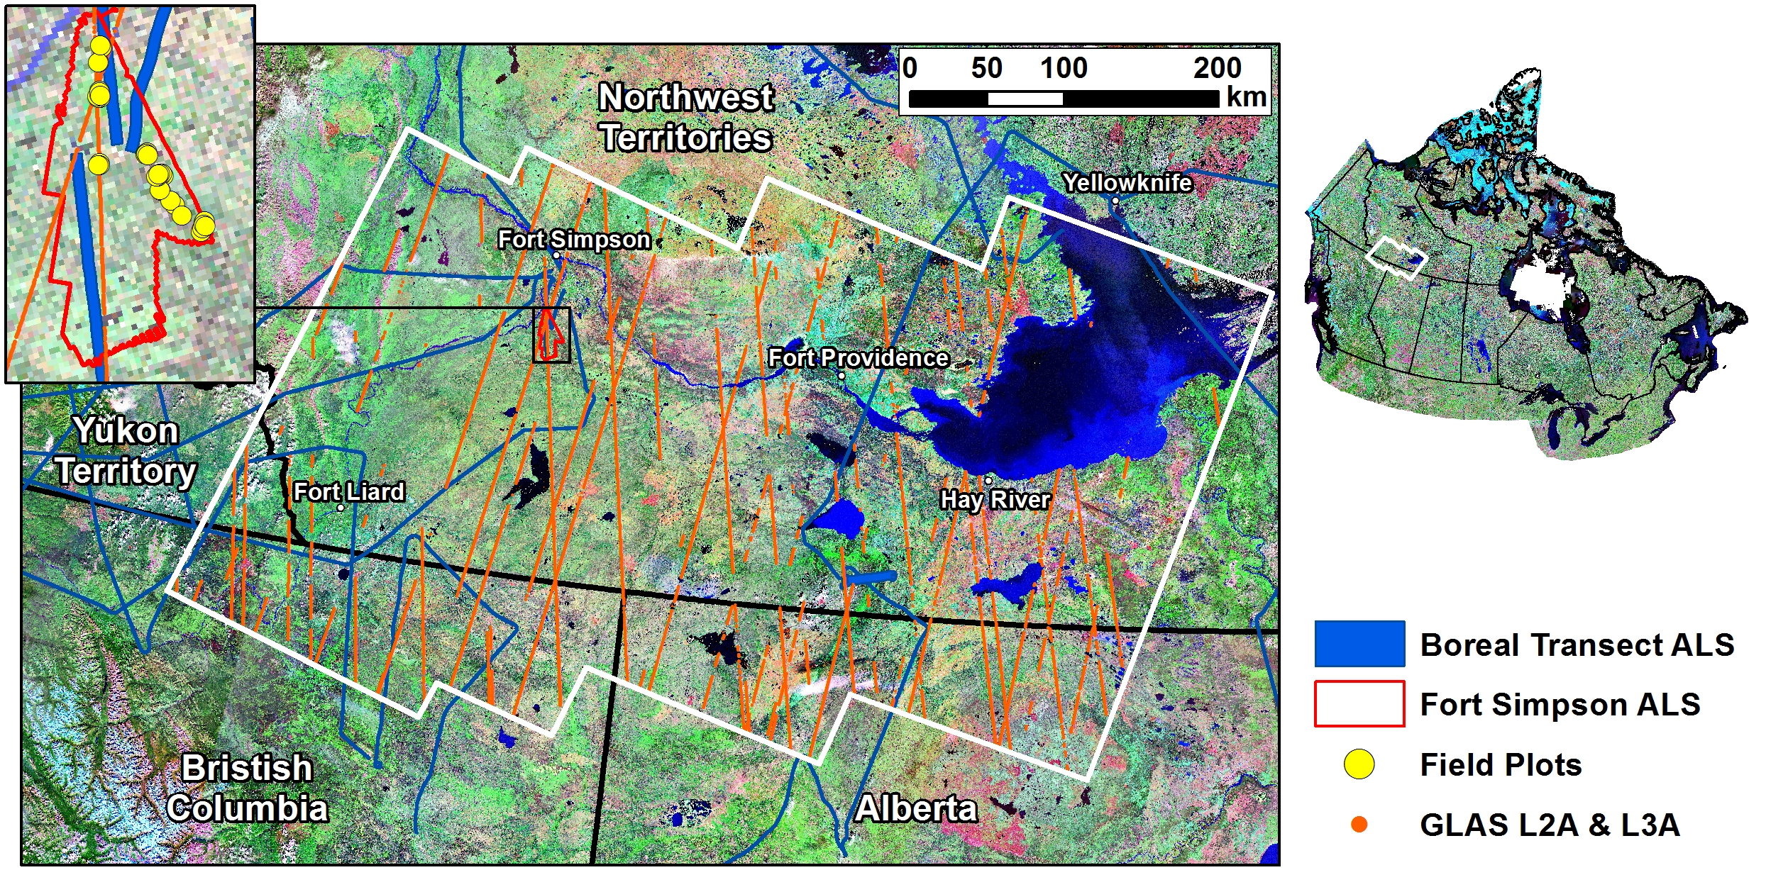

Figure . Location of the region of interest (ROI) and the distribution of various data sources throughout, including: field plot, ALS, and spaceborne laser altimetry data.

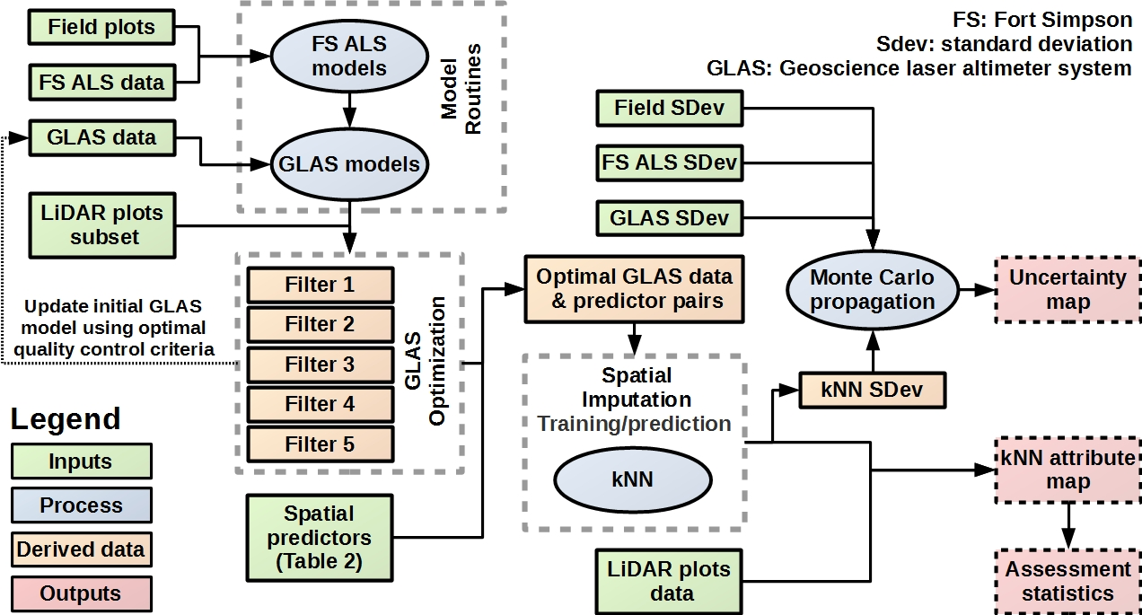

Figure . General workflow of the developed methodological framework. Note, merged data refers to the each set of filtered data (response and predictor attributes) being submitted to the k-NN algorithm.

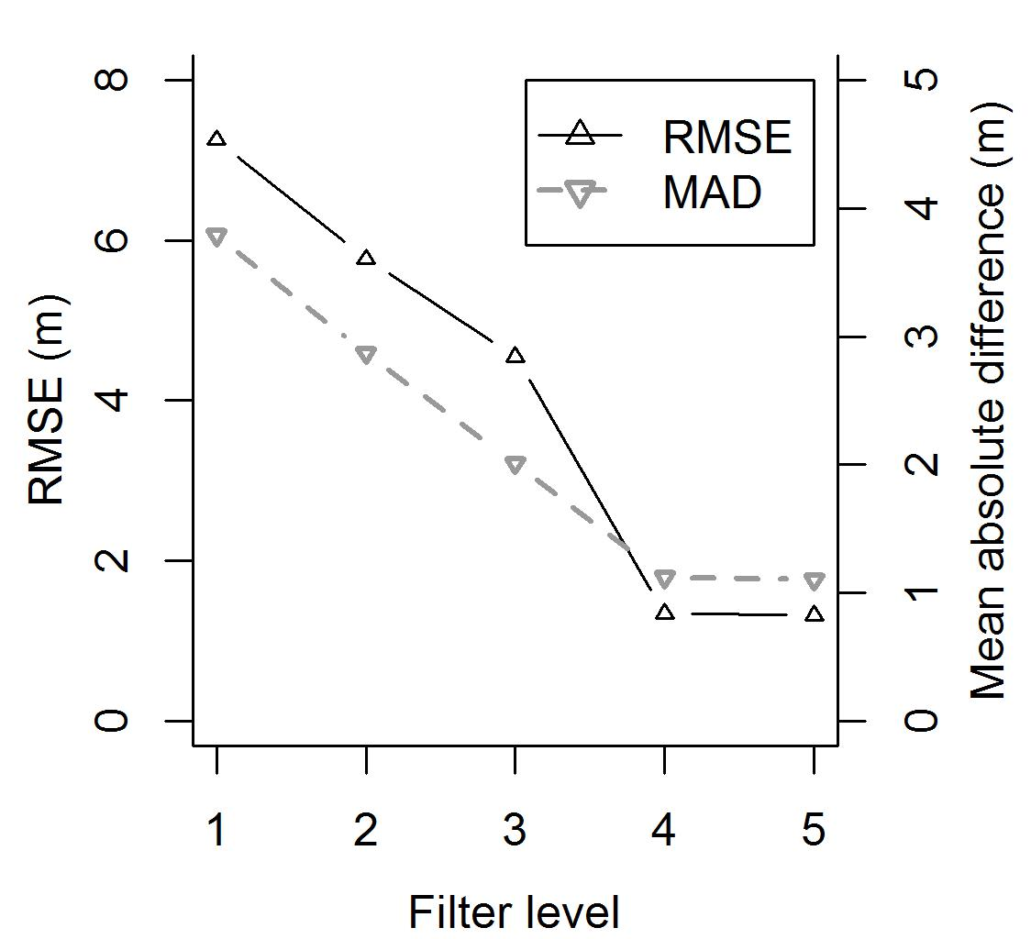

Figure Summary of the change of root mean squared error (RMSE) and mean absolute difference (MAD) noted between intersecting GLAS and LiDAR plots estimates of stand height as a function of five different levels of quality control.

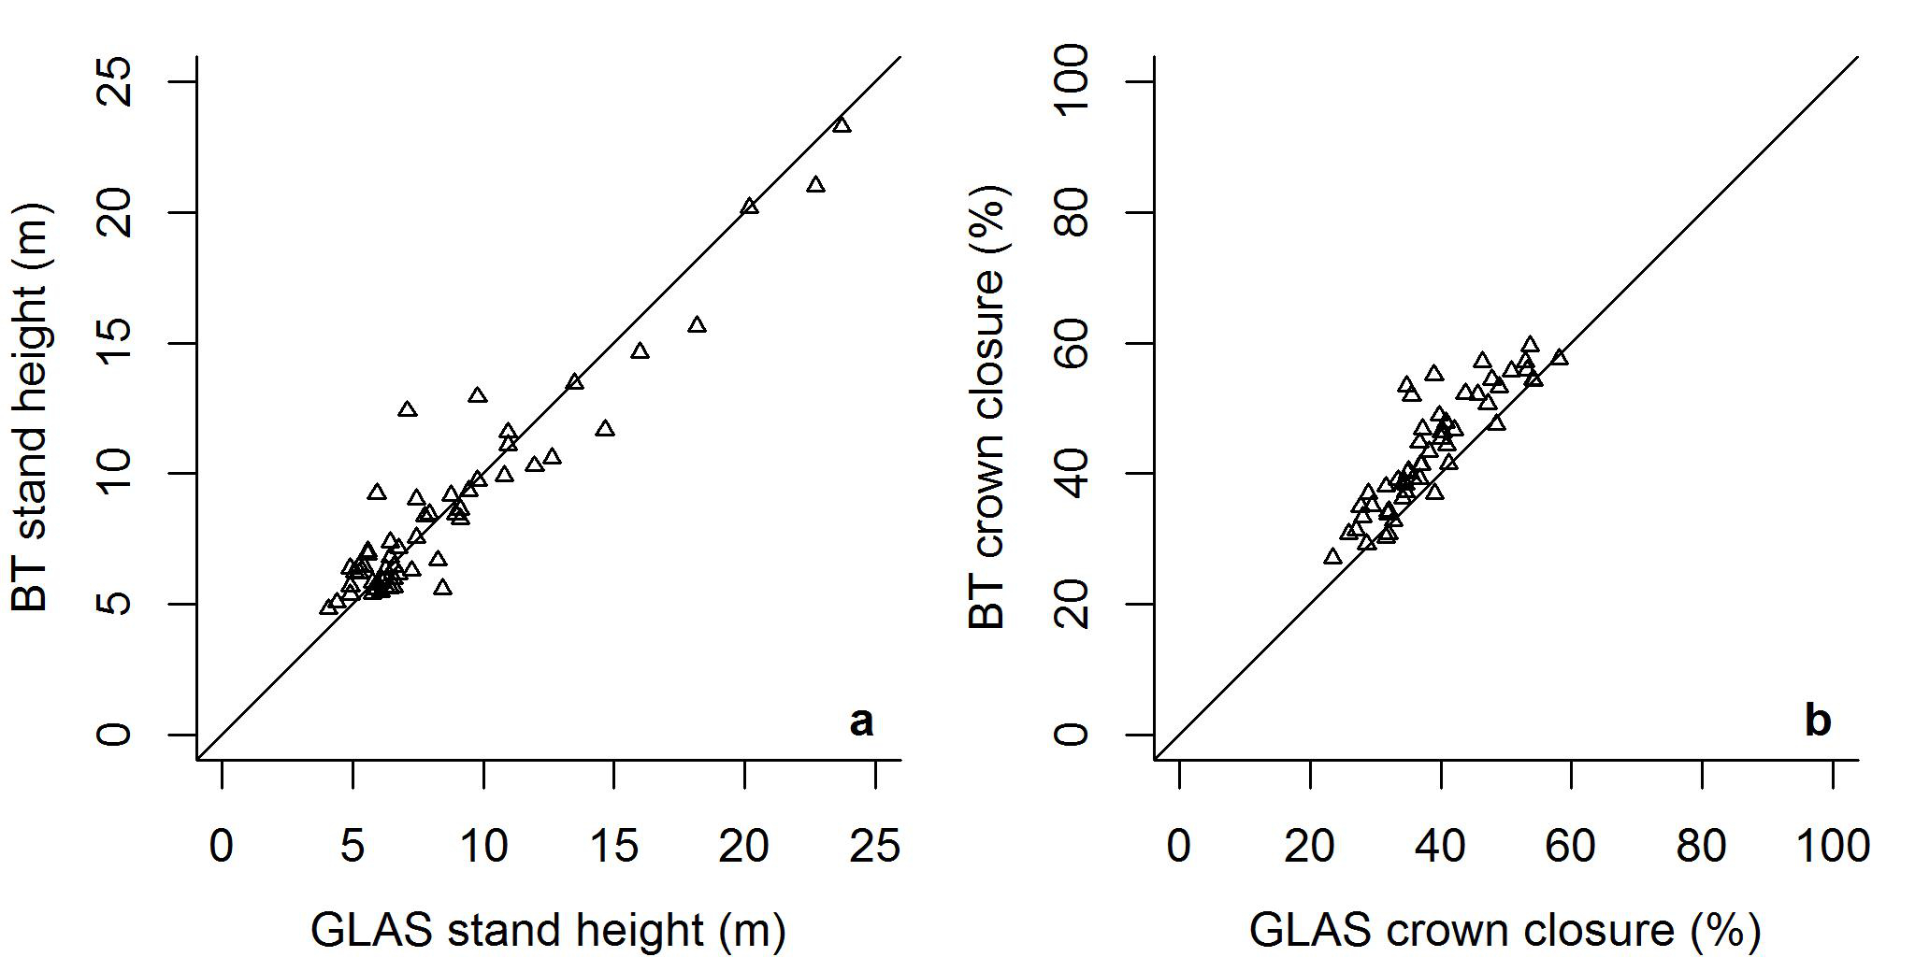

Figure Comparison of GLAS modelled a) stand height and b) crown closure with 55 conicident LiDAR plots survey data points.

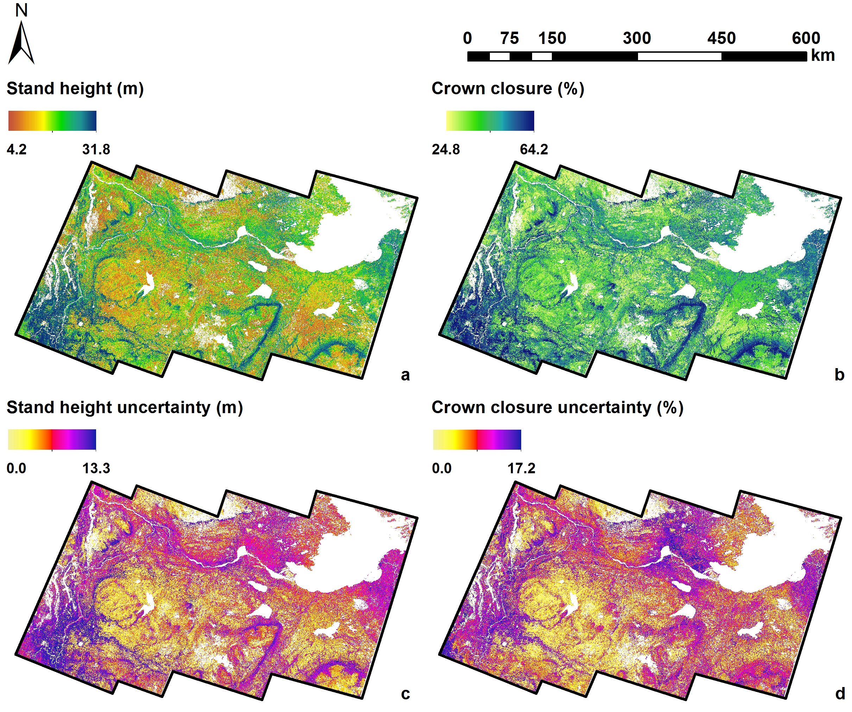

Figure k-NN mapped a) stand height and b) crown closure, and associated uncertainties mapped for c) stand height, and d) crown closure.

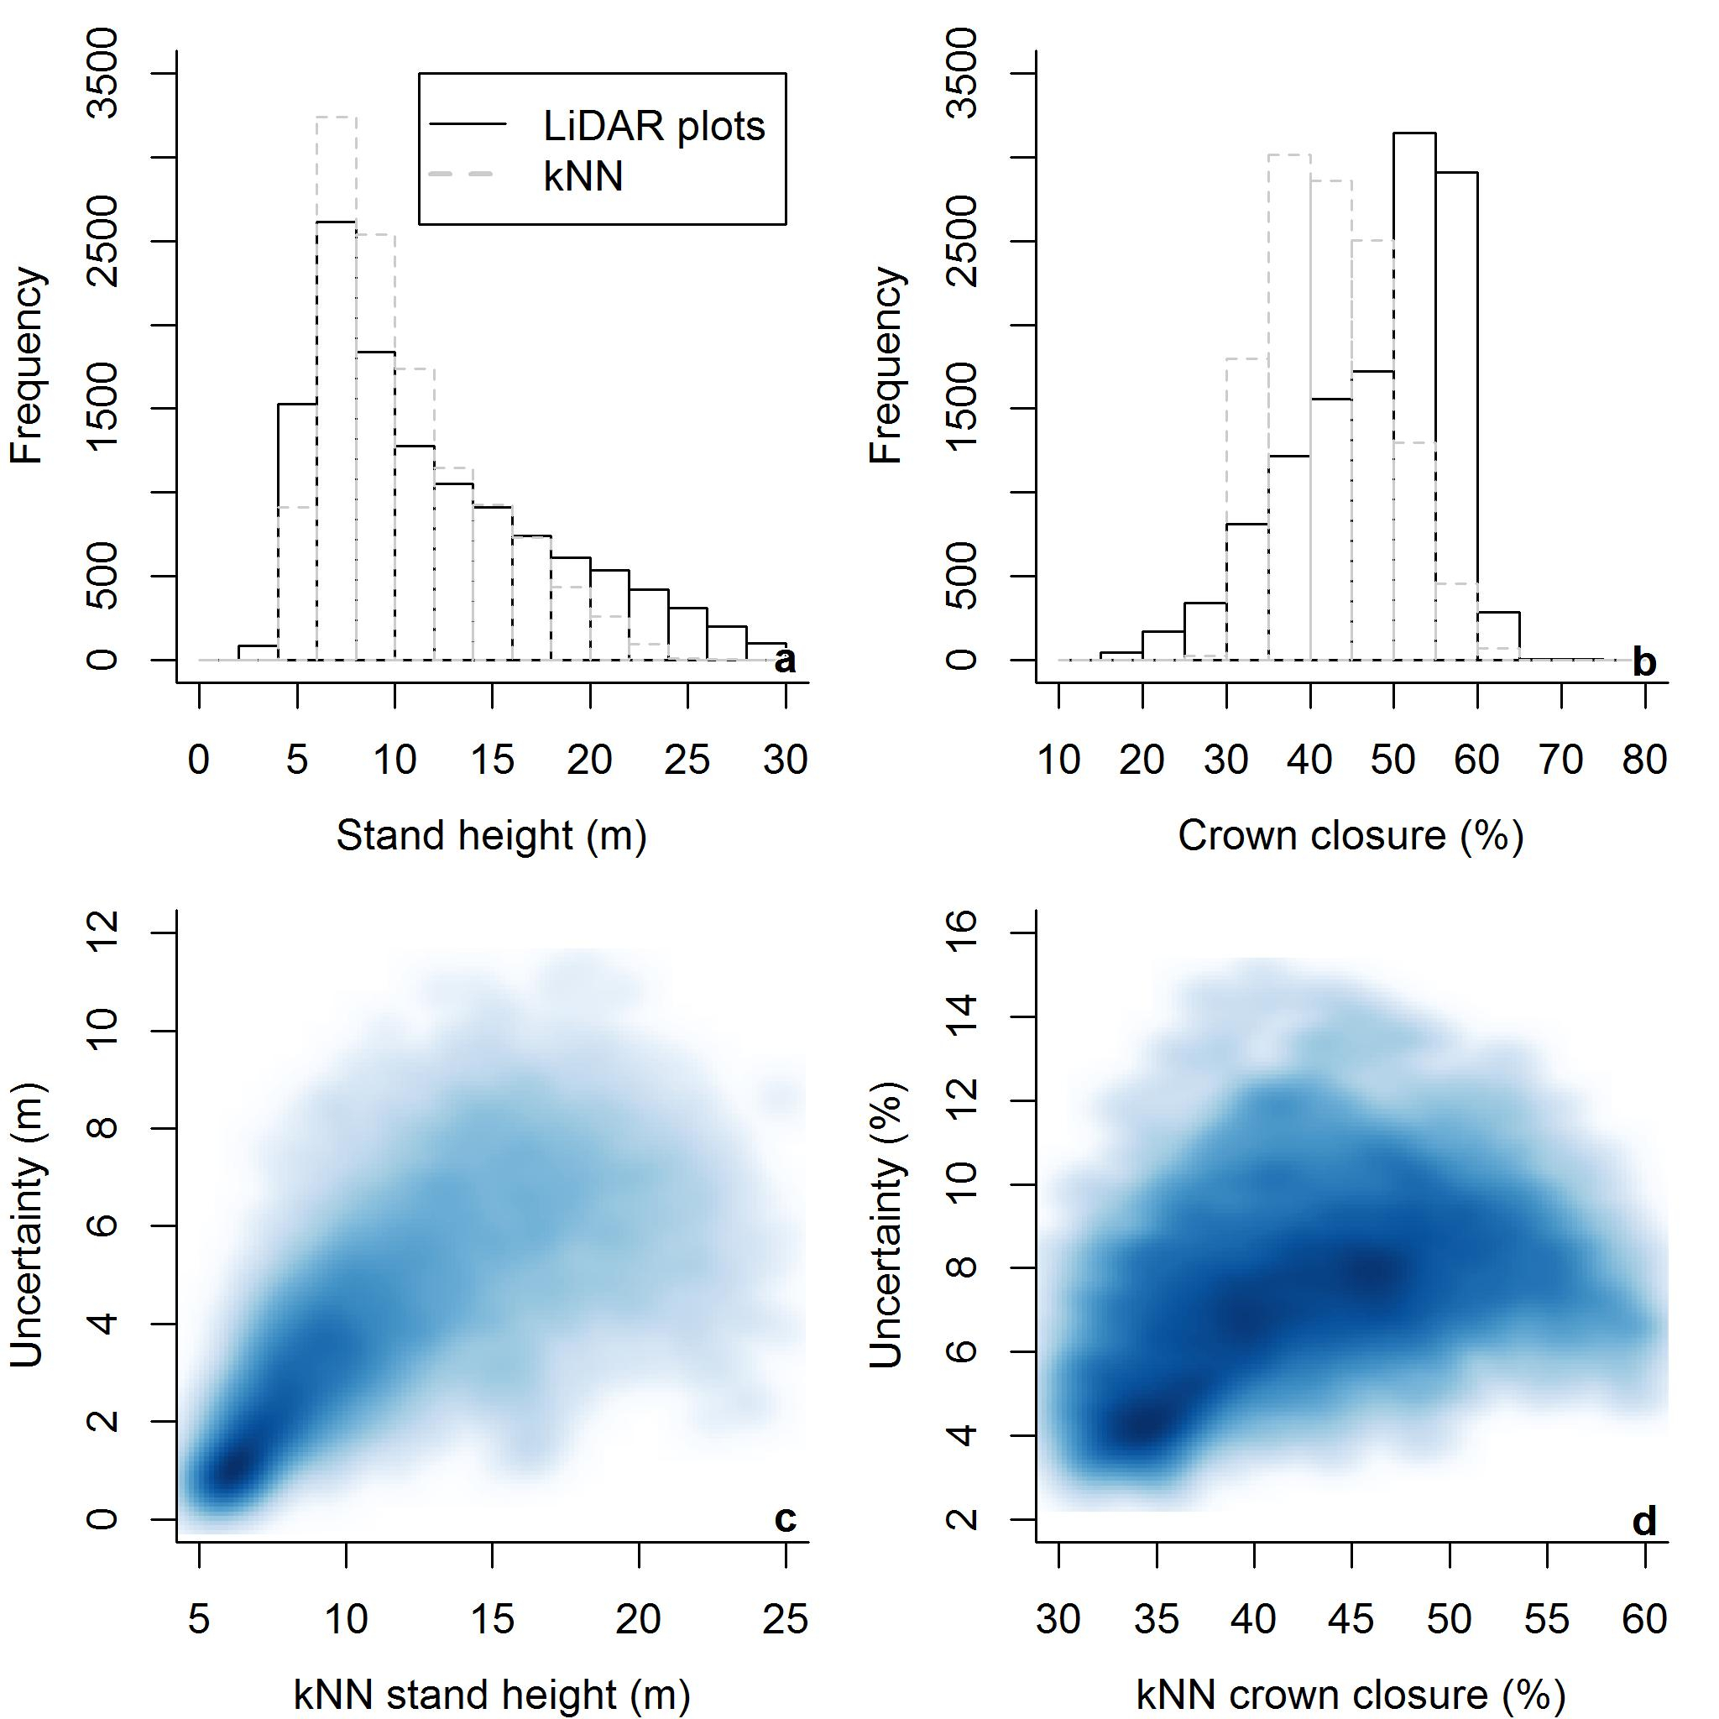

Figure Comparisons of LiDAR plots ALS and regionally mapped k-NN distributions of a) stand height, and b) crown closure, and the relationship between k-NN attributes and their associated uncertainties for c) stand height, and d) crown closure (darker shades indicate higher point density). Comparisons are based on 1% of intersecting LiDAR plots data, resulting in 12195 points.Supplementary Material

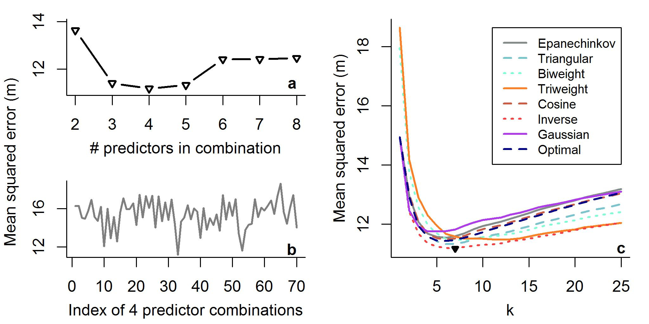

Supplementary Figure Visualization of the k-NN optimization for stand height. Component a) illustrates which number of predictors (4 in this case) is best via mean squared error (MSE), b) illustrates which combination of 4 predictors produces the lowest MSE (combination 33), and c) optimizes predictor combination 33 for k (7 in this case) and weighting kernel (inverse in this case) through a k-NN training process .

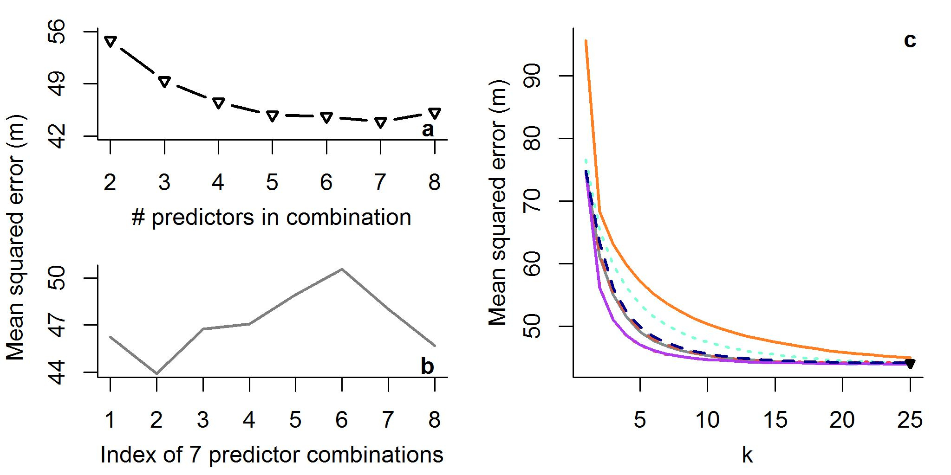

Supplementary Figure Visualization of the k-NN optimization for crown closure. In this case a) illustrates 7 predictors as best via mean squared error, b) illustrates combination 2 provides optimal predictors, and c) illustrates k=25 and the triangular weighting kernel produces an optimal k-NN model.

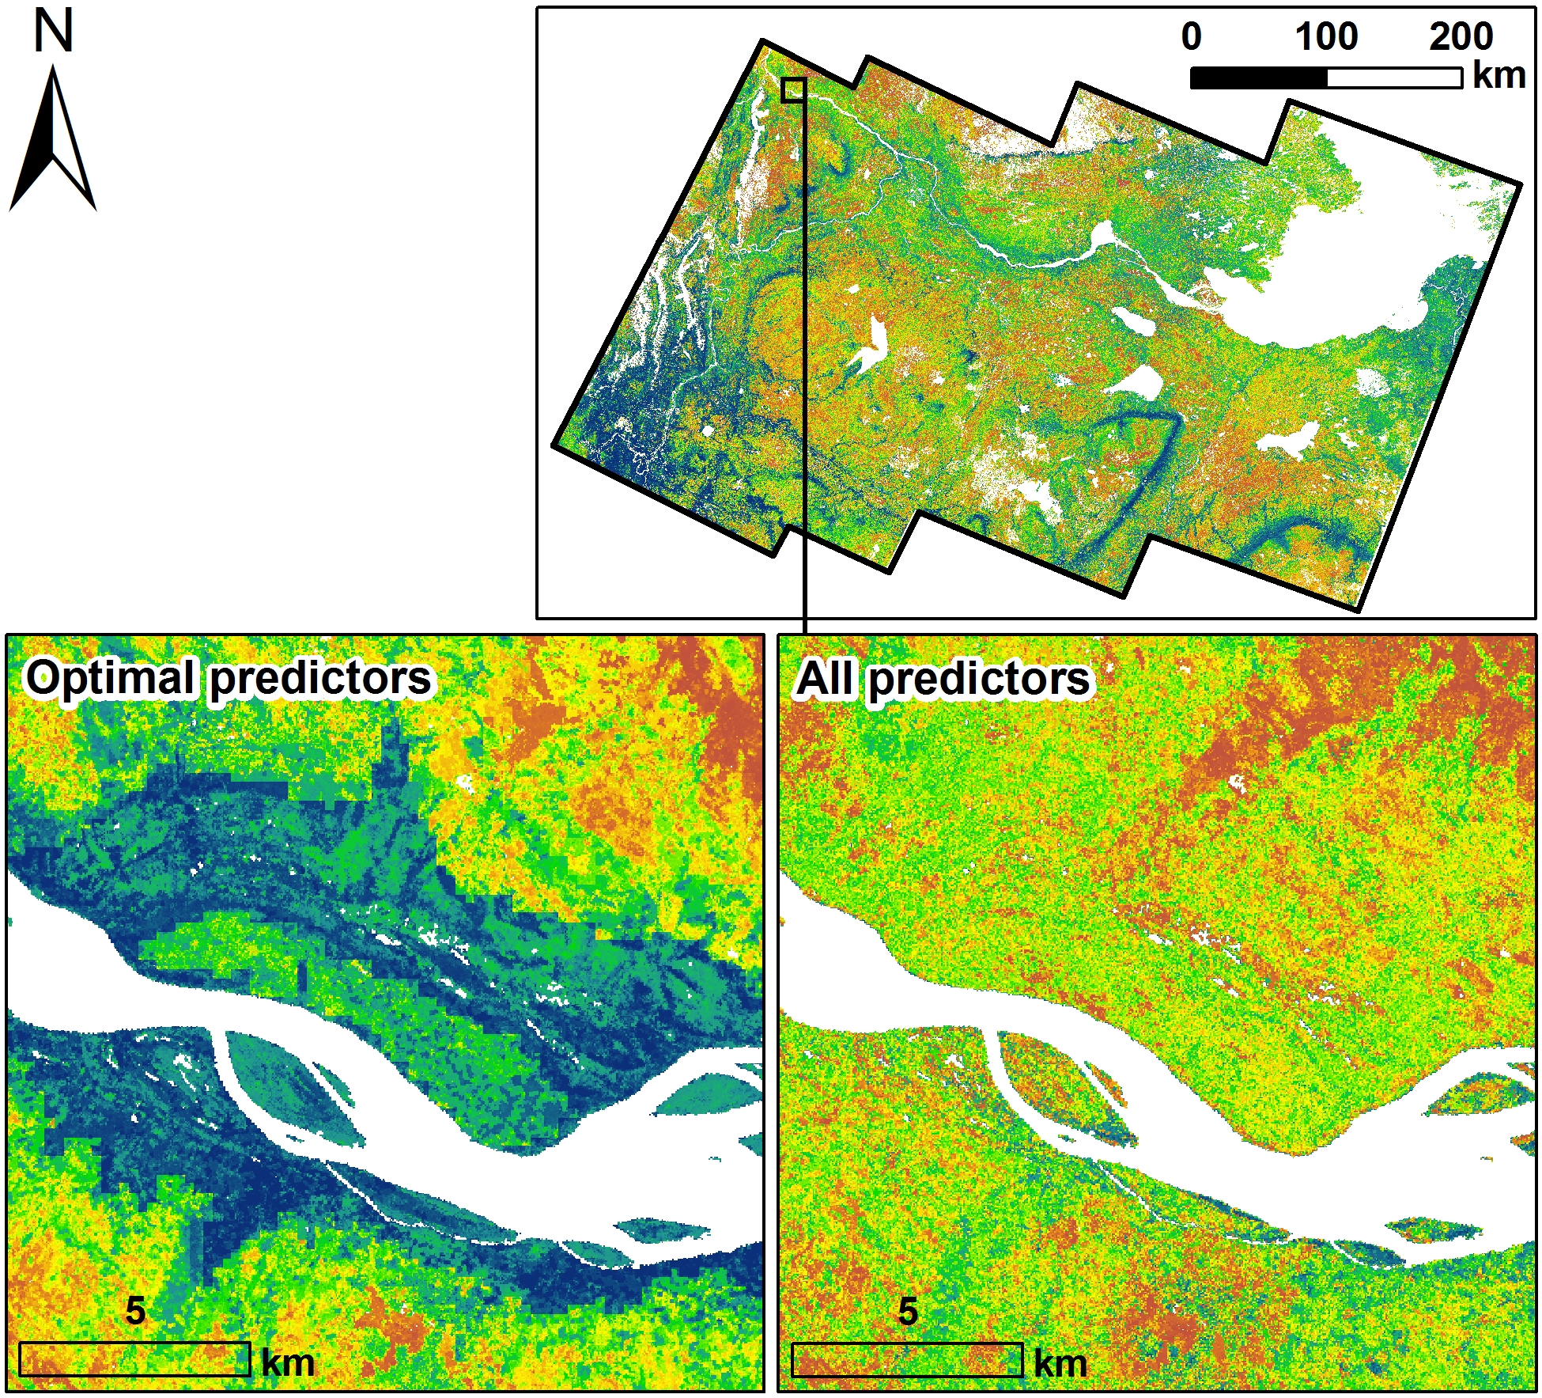

Supplementary Figure Visual comparison of regionally mapped stand height from k-NN (holding the number of neighbours and weighting kernel constant) employing an optimal predictor set only, and utilizing all available predictors. Note, the propagation of artificial boundaries where the optimal predictor set is employed.

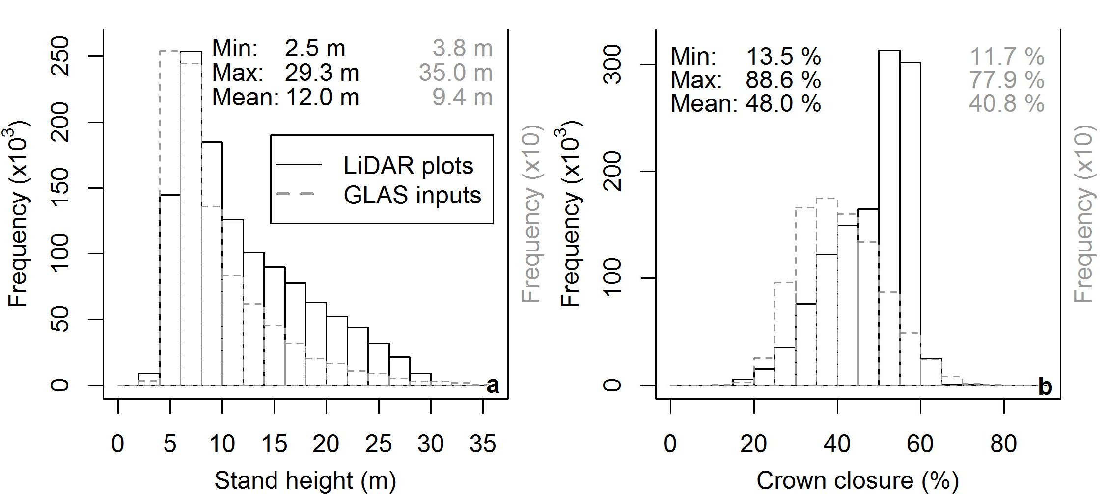

Supplementary Figure Distributions of all LiDAR plots ALS data and optimal GLAS data utilized to drive k-NN models for a) stand height, and b) crown closure. Descriptive statistics (minimum, maximum, and mean) associated with each data source demonstrate the similarities or differences.